A REPORT CONCERNING THE PAST, PRESENT, AND FUTURE OF THE COCK AND BULL COFFEE SHOP AND PUB

ROBERT CERJANEC
VICE PRESIDENT OPERATIONS
FOUNDERS COLLEGE STUDENT COUNCIL
2009-2010

JUNE 2009

Table of Contents

Report June 2009 3

Appendix A 8

Appendix B 9

Appendix C 11

Appendix D 14

Appendix E 15

Appendix F 17

Appendix G 18

Historical Report March 1974 19

The Cock and Bull was started in 1966 as a coffee chop in the basement of Founders College by some Founders College students who wanted to improve the quality of life of Founders College with the idea that a coffee shop would benefit students. Over the next couple of years through volunteer work, the coffee shop became a unique place on campus and a place that Founders College students could call home. Over time the Cock and Bull turned into a pub operation on a regular basis using a caterer to sell alcohol. Immediately the Cock and Bull became a huge success, with many students realizing the importance of such a space, using it frequently during the day as a coffee shop and as a pub in the evening. The Cock and Bull became a place of employment for Founders College students and contributed to campus life. The Cock and Bull had the reputation of being the most popular and successful pub on campus in the early 1970s up until its closure in late 2007.
Fast-forward to the year 2009 and the Cock and Bull is not running anymore. The Cock and Bull was in operation for 41 years from 1966 to 2007 with a good majority of that time period being run by Founders College Student Council as a place for students to distress, socialize, debate, bond with fellow students, and enjoy their time at university. Looking at the history and talking to past and current students who were able to have the Cock and Bull experience, they felt that the Cock and Bull was an important place on campus and a place where many memories were had over the years.
When looking at the year 1997, the Cock and Bull was by far the most successful coffee shop/pub on campus with gross sales of over $500,000. The next highest grossing pub had sales of just over $300,000. (Appendix A) Up until the year 1999 Founders College Student Council had full control over the Cock and Bull but due to changing liquor license requirements, the University was no longer responsible for the sale of alcohol on campus and individual licenses had to be acquired. (Appendix B)
The requirement of an individual liquor license resulted in the Cock and Bull being unilaterally appropriated by York University, the Masters Office, and York University Business Facilities and Operations without any discussion and input from Founders College Student Council. (Appendix C) In the events preceding this, Founders College Student Council re-iterated their position on the Cock and Bull. They determined that Founders College Student Council owned the Cock and Bull through an official ruling by the University. (Appendix D) Following the appropriation of the Cock and Bull, Founders College Student Council was forced to negotiate the terms of the agreement after the fact and this resulted in a disposition of funds totaling $75,000 to be distributed by Founders College Student Council. Through this agreement, Founders College Student Council retained ownership of all pub equipment, furniture, and the businesses name with the intention to ensure the Cock and Bull’s existence at Founders College and York University. (Appendix E)
Unfortunately in December of 2007, the Cock and Bull when being operated by Sodexho, ceased operations and has been closed since. An institution at York and Founders College that was open for 41 years ceased to exist. This institution was a place for people to meet other members of the York community, engage in discussion, have a coffee, enjoy a night out, and feel apart of a small community within the much larger York community. The Cock and Bull connected people, bringing together a diversity of backgrounds, opinions, talents, and ideas. Due to the complexity and liability of liquor operations and the availability of many other liquor options in and around the York campus, the solution for the Cock and Bull is not to serve liquor at this present point in time. However, there remains an opportunity for the space to become a coffee shop run by students for students, which was the original idea and mandate of the Cock and Bull Coffee Shop. I believe that this is possible and attractive alternative, and a space that would have a great impact on the pride and joy of York University students, Founders College students, and students in the Complex One area.
There are numerous coffee options on York’s Keele campus ranging from Second Cup to the coffee available in the Complex One cafeteria. The difference between these businesses and a revival of the Cock and Bull Coffee Shop is that the Cock and Bull would be run by students for students with affordable prices on coffee, espresso, other drinks, and a small amount of food products as well. It will provide a sense of pride and meaning for students going to York University. A revived Cock and Bull Coffee Shop would enhance the Founders College and Complex One community, and be once again a unique place on this campus where people can go to and have a good and affordable cup of coffee.
In addition to selling coffee and food items, the Cock and Bull can become a place where students, faculty, Fellows, and artists’ artwork can be prominently displayed, open mic nights can be hosted, student bands can perform, and the Masters Office and Founders College Student Council can work in collaboration and partnership in using the space for events which aim to build the Founders College community. The Cock and Bull is an intimate and accessible space in a prime location within Complex One and its use will benefit students within our community and keep alive a tradition that was in operation for 41 years.
The Cock and Bull can be a successful enterprise without the sale of alcohol. Past income statements support such a claim. The Cock and Bull only needs to break even in order to provide the maximum benefit towards students. From the year 1992 to the year 1998, the Cock and Bull’s gross sales went from $258,363 to $592,496 and during this time period the Net Income ranged from -$35,611 to $54,056. (Appendix F) When looking at the breakdown of sales from May 1, 1998 to January 1, 1999, the Cock and Bull took in gross sales of $387,408.15. A further breakdown reveals that the total gross sales of alcoholic beverages were $194,021.97 while the gross sales of food and non-alcoholic beverages were $193,386.18. This is almost a 50-50 split in regards to sales. (Appendix G)
The expenses of running a bar with alcohol include; the hiring of bartenders, servers, and security, and not to mention the liability risks as well. A coffee shop would not need a large staff, only one to two people to work behind the counter at a given time serving beverages and a limited amount of food items. In addition, if the Cock and Bull were to serve a limited amount of food, the need for a chef and kitchen staff is non-existent. These two categories of employees are not required in the operation of a coffee shop and would significantly reduce the amount of money needed to pay employees. Staff levels can be adjusted according to the business needs and sales.
Some capital improvements will be required to open a coffee shop, most notably a counter space, cash register, coffee brewing machine, espresso machine, bagel toaster, possibly a refrigeration unit, and some other small items. These expenses can be spread out over a number of years. The furnishings in the Cock and Bull are suitable for a coffee shop layout and do not need upgrading.
This report touches on the historical background of the Cock and Bull, it’s importance to Founders College students and the York community, the past issues regarding the Cock and Bull, and a brief plan and understanding for a revival of the Cock and Bull Coffee Shop. It is important to note that a revived Cock and Bull will operate as a student service with a purpose to provide a service to the students of Founders College and the York community at the lowest possible cost for students. The goal is community building and having a college and university that we can all be proud of. 41 years of history and community should not be forgotten and that is the goal of this report. Attached are Appendixes A through G and a report dated March 1974 by the Manager of the Cock and Bull, Doug Ross. I would be more than pleased to discuss this report in person and my vision for the future of the Cock and Bull Coffee Shop within the Founders College, Complex One, and York communities.

Yours truly,

Robert Cerjanec
Vice President Operations
Founders College Student Council

Appendix A
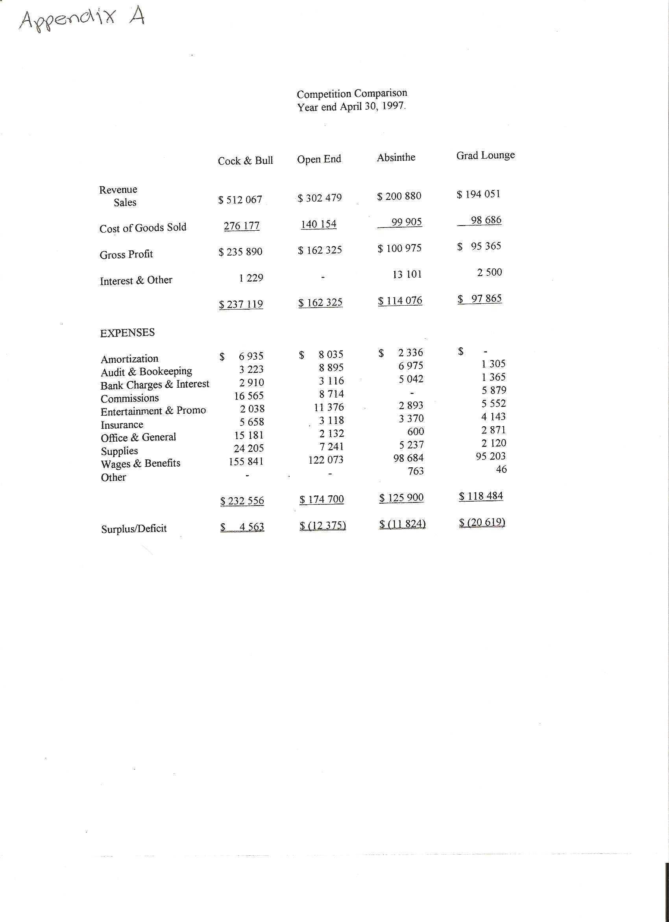

Appendix B

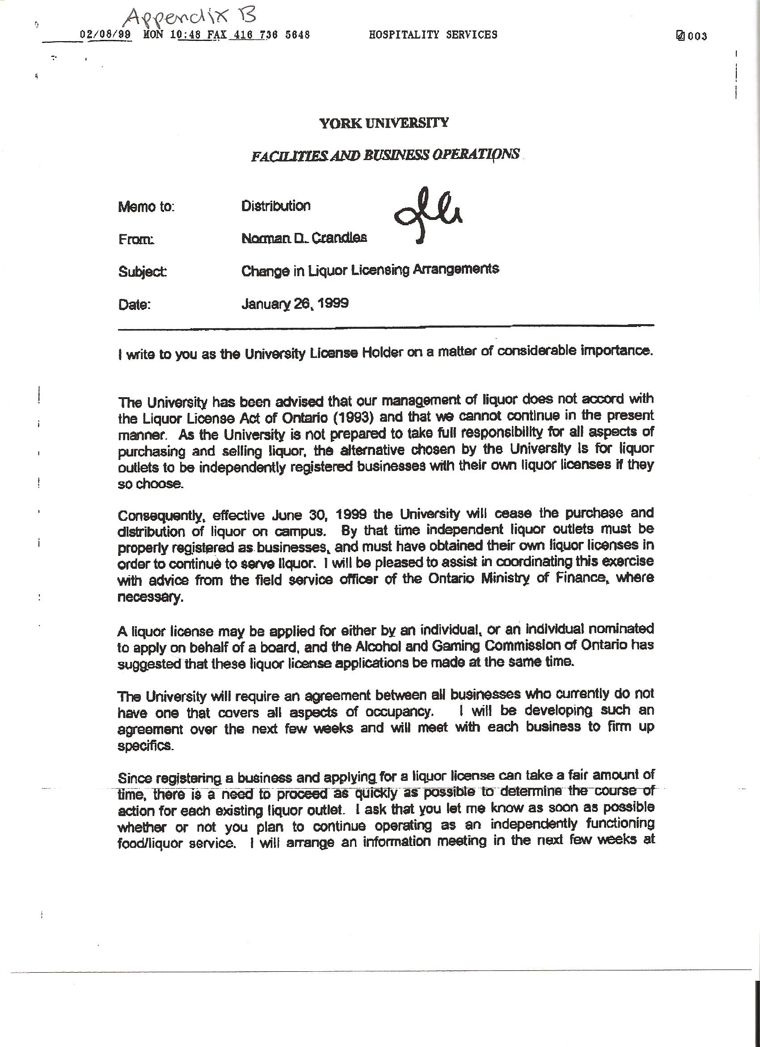

Appendix B-Continued
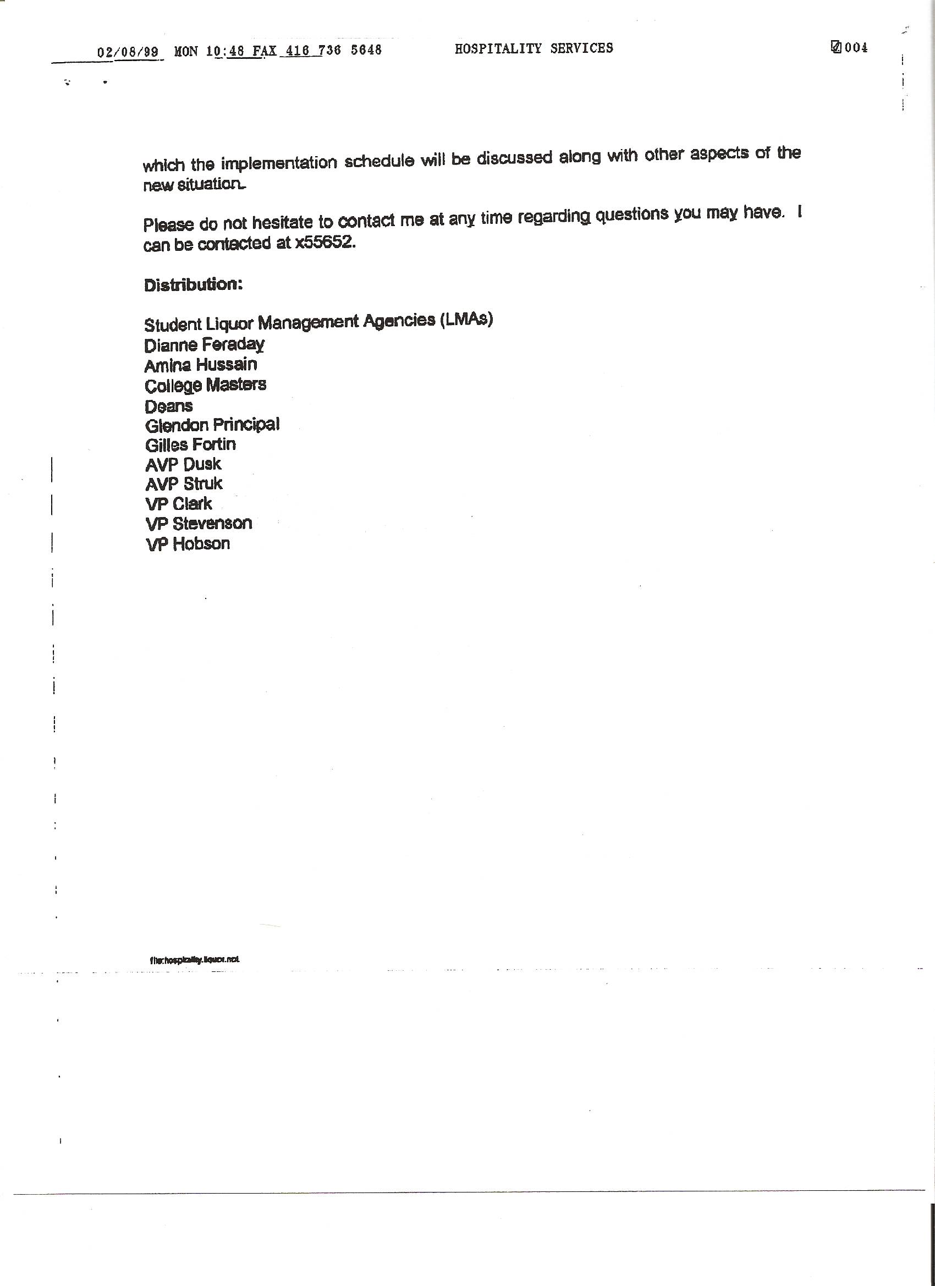

Appendix C
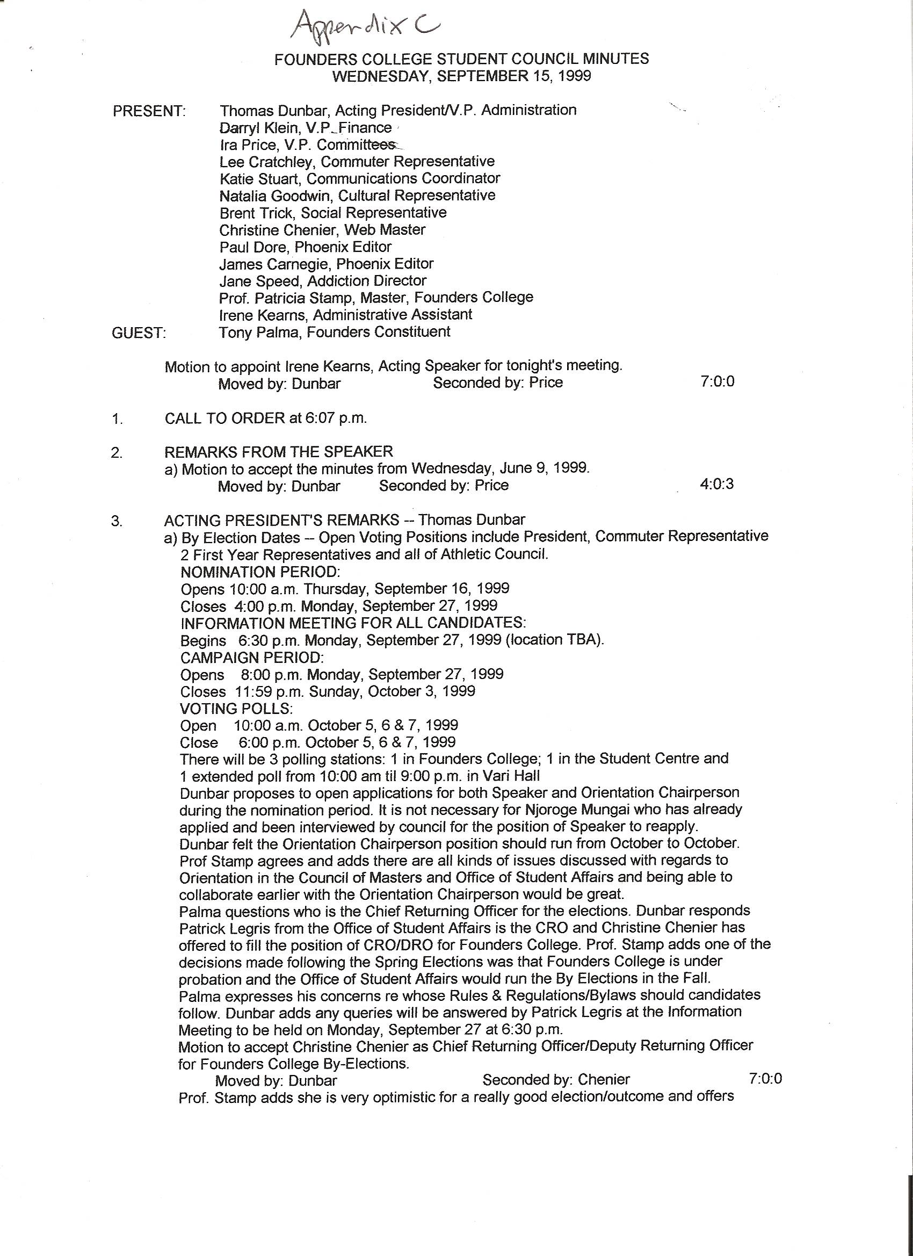

Appendix C-Continued
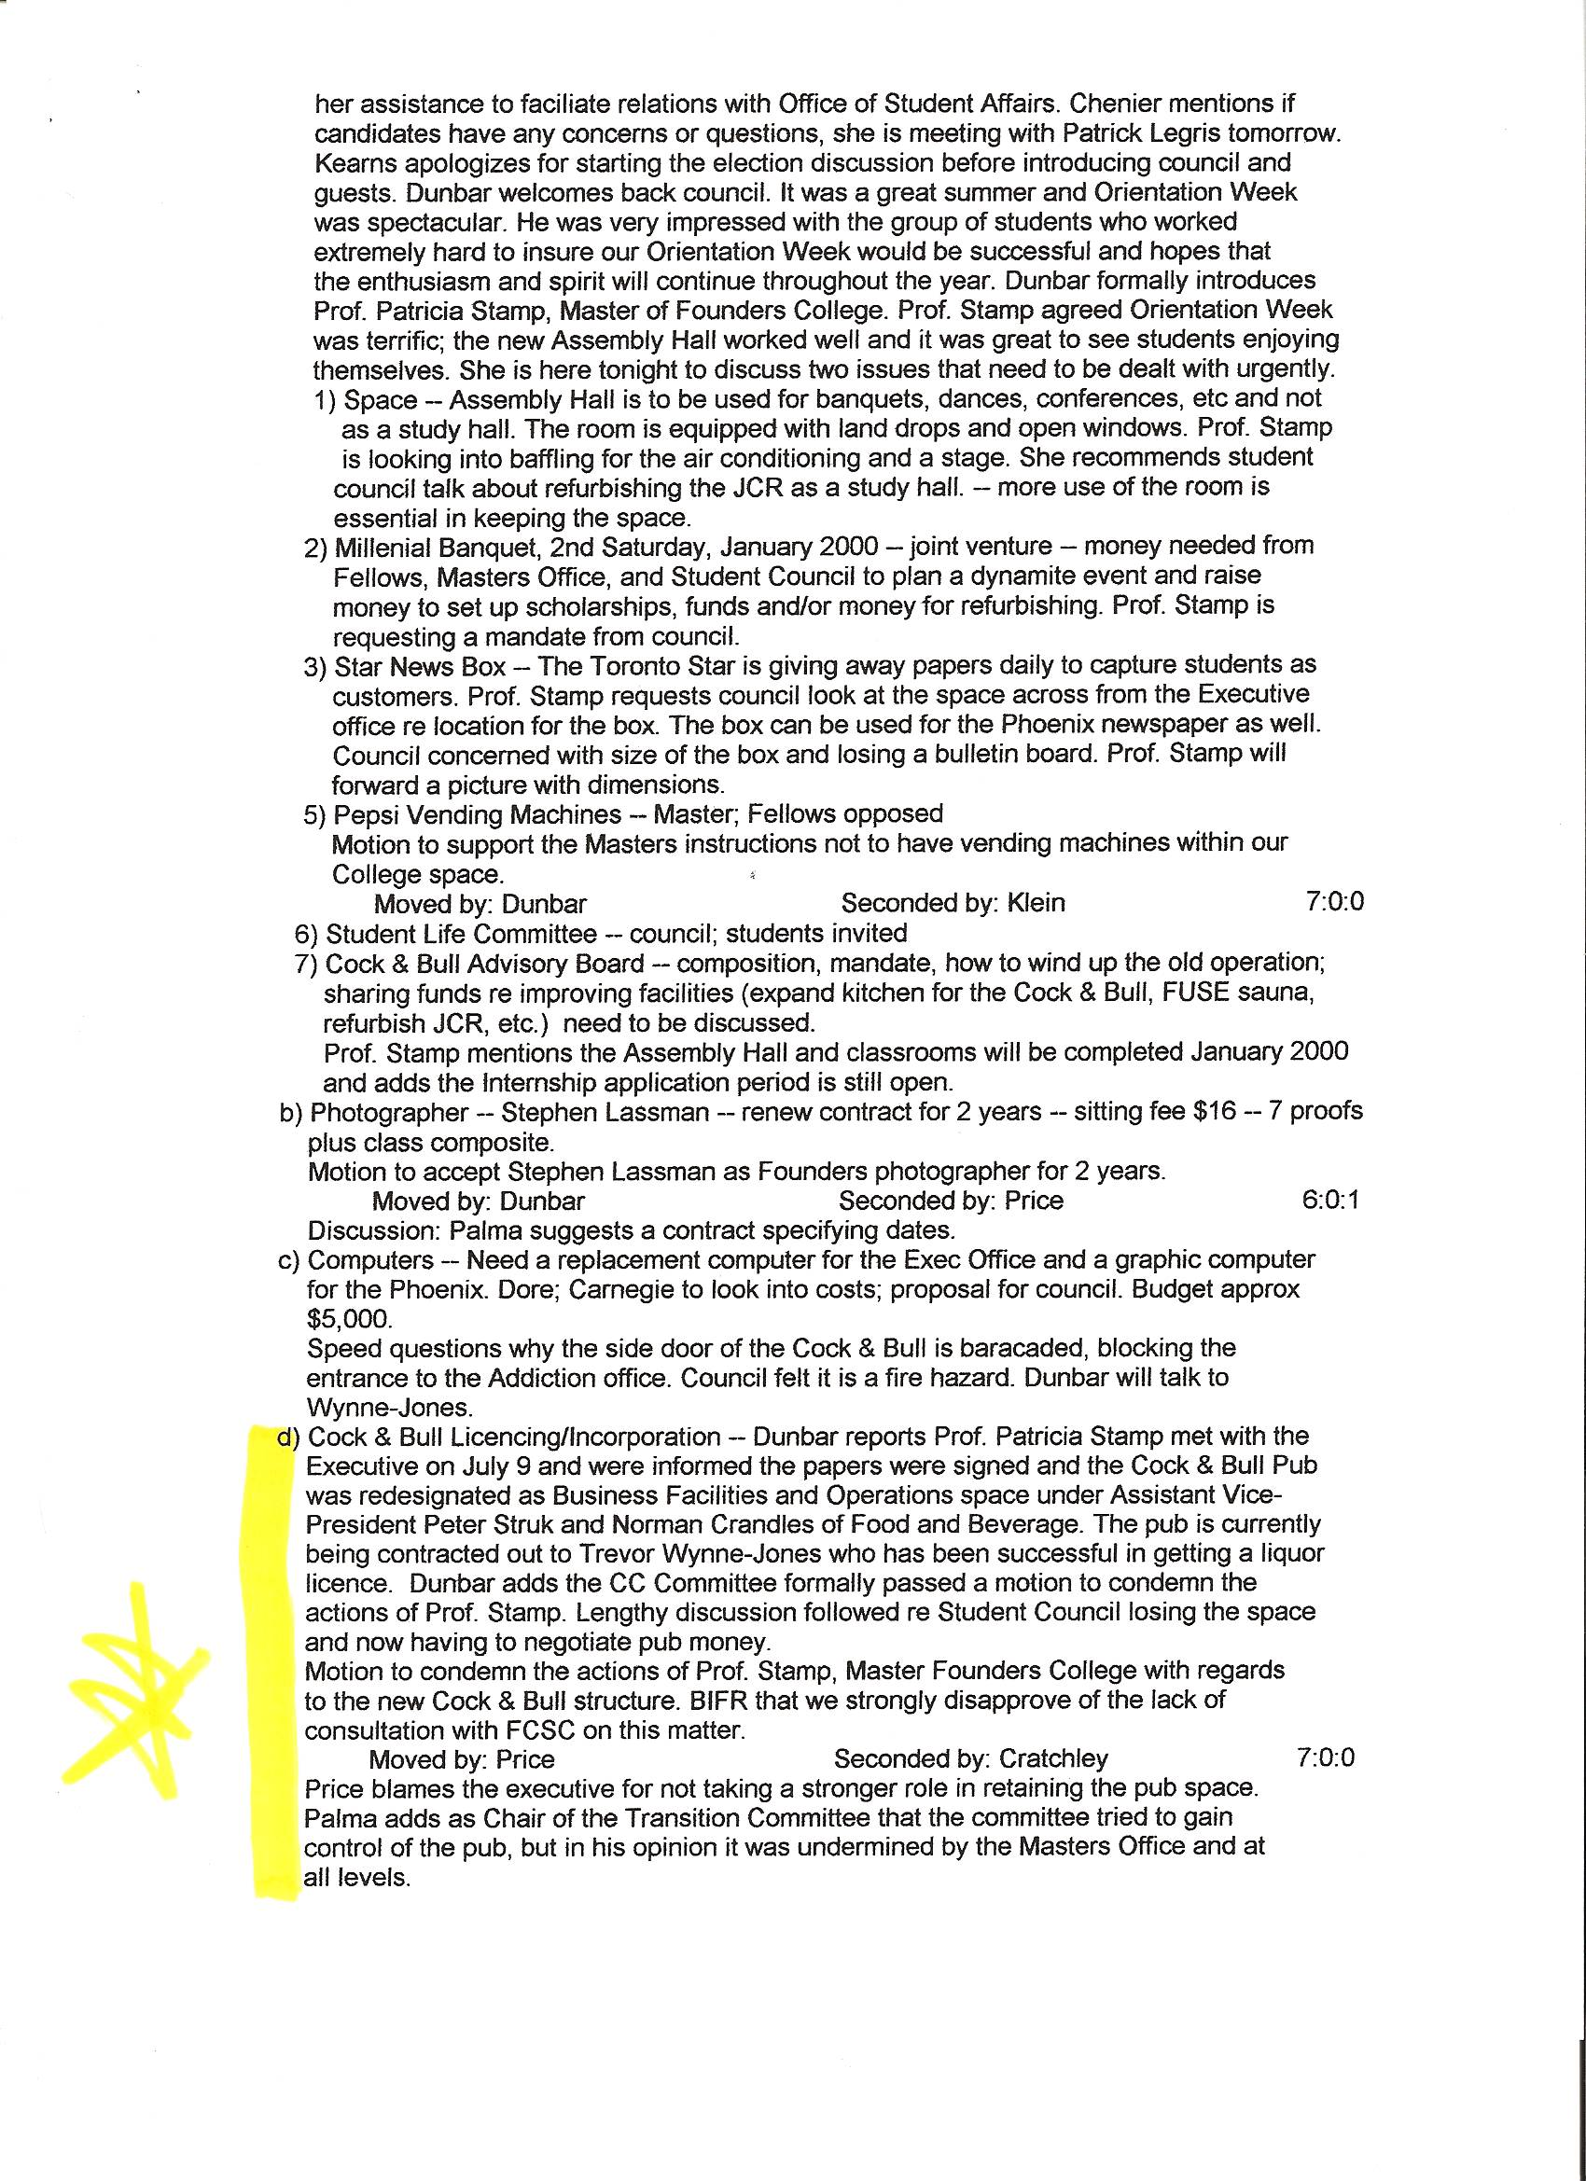

Appendix C-Continued
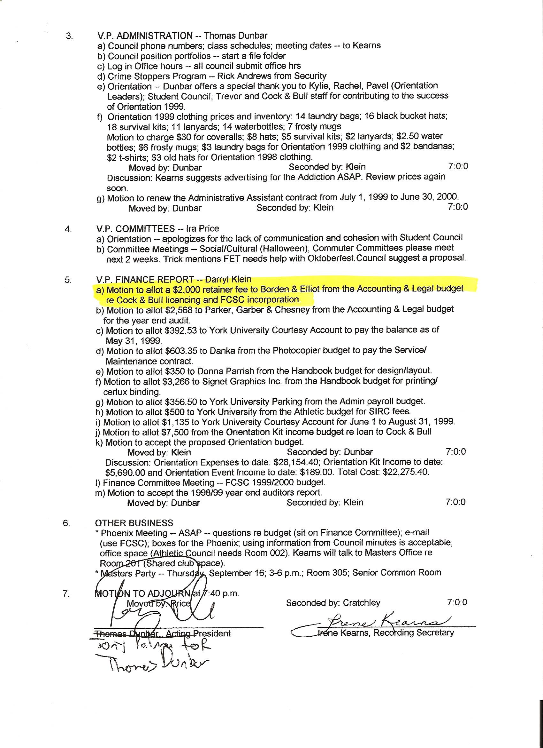

Appendix D
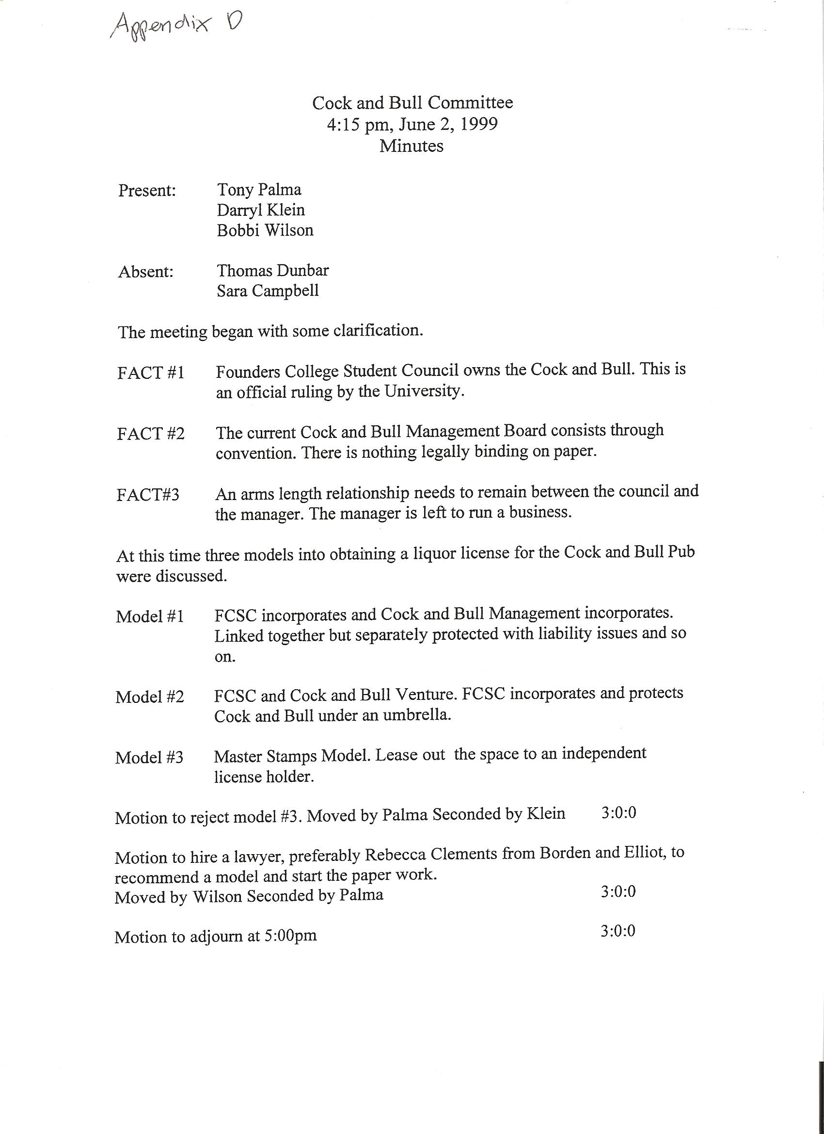

Appendix E
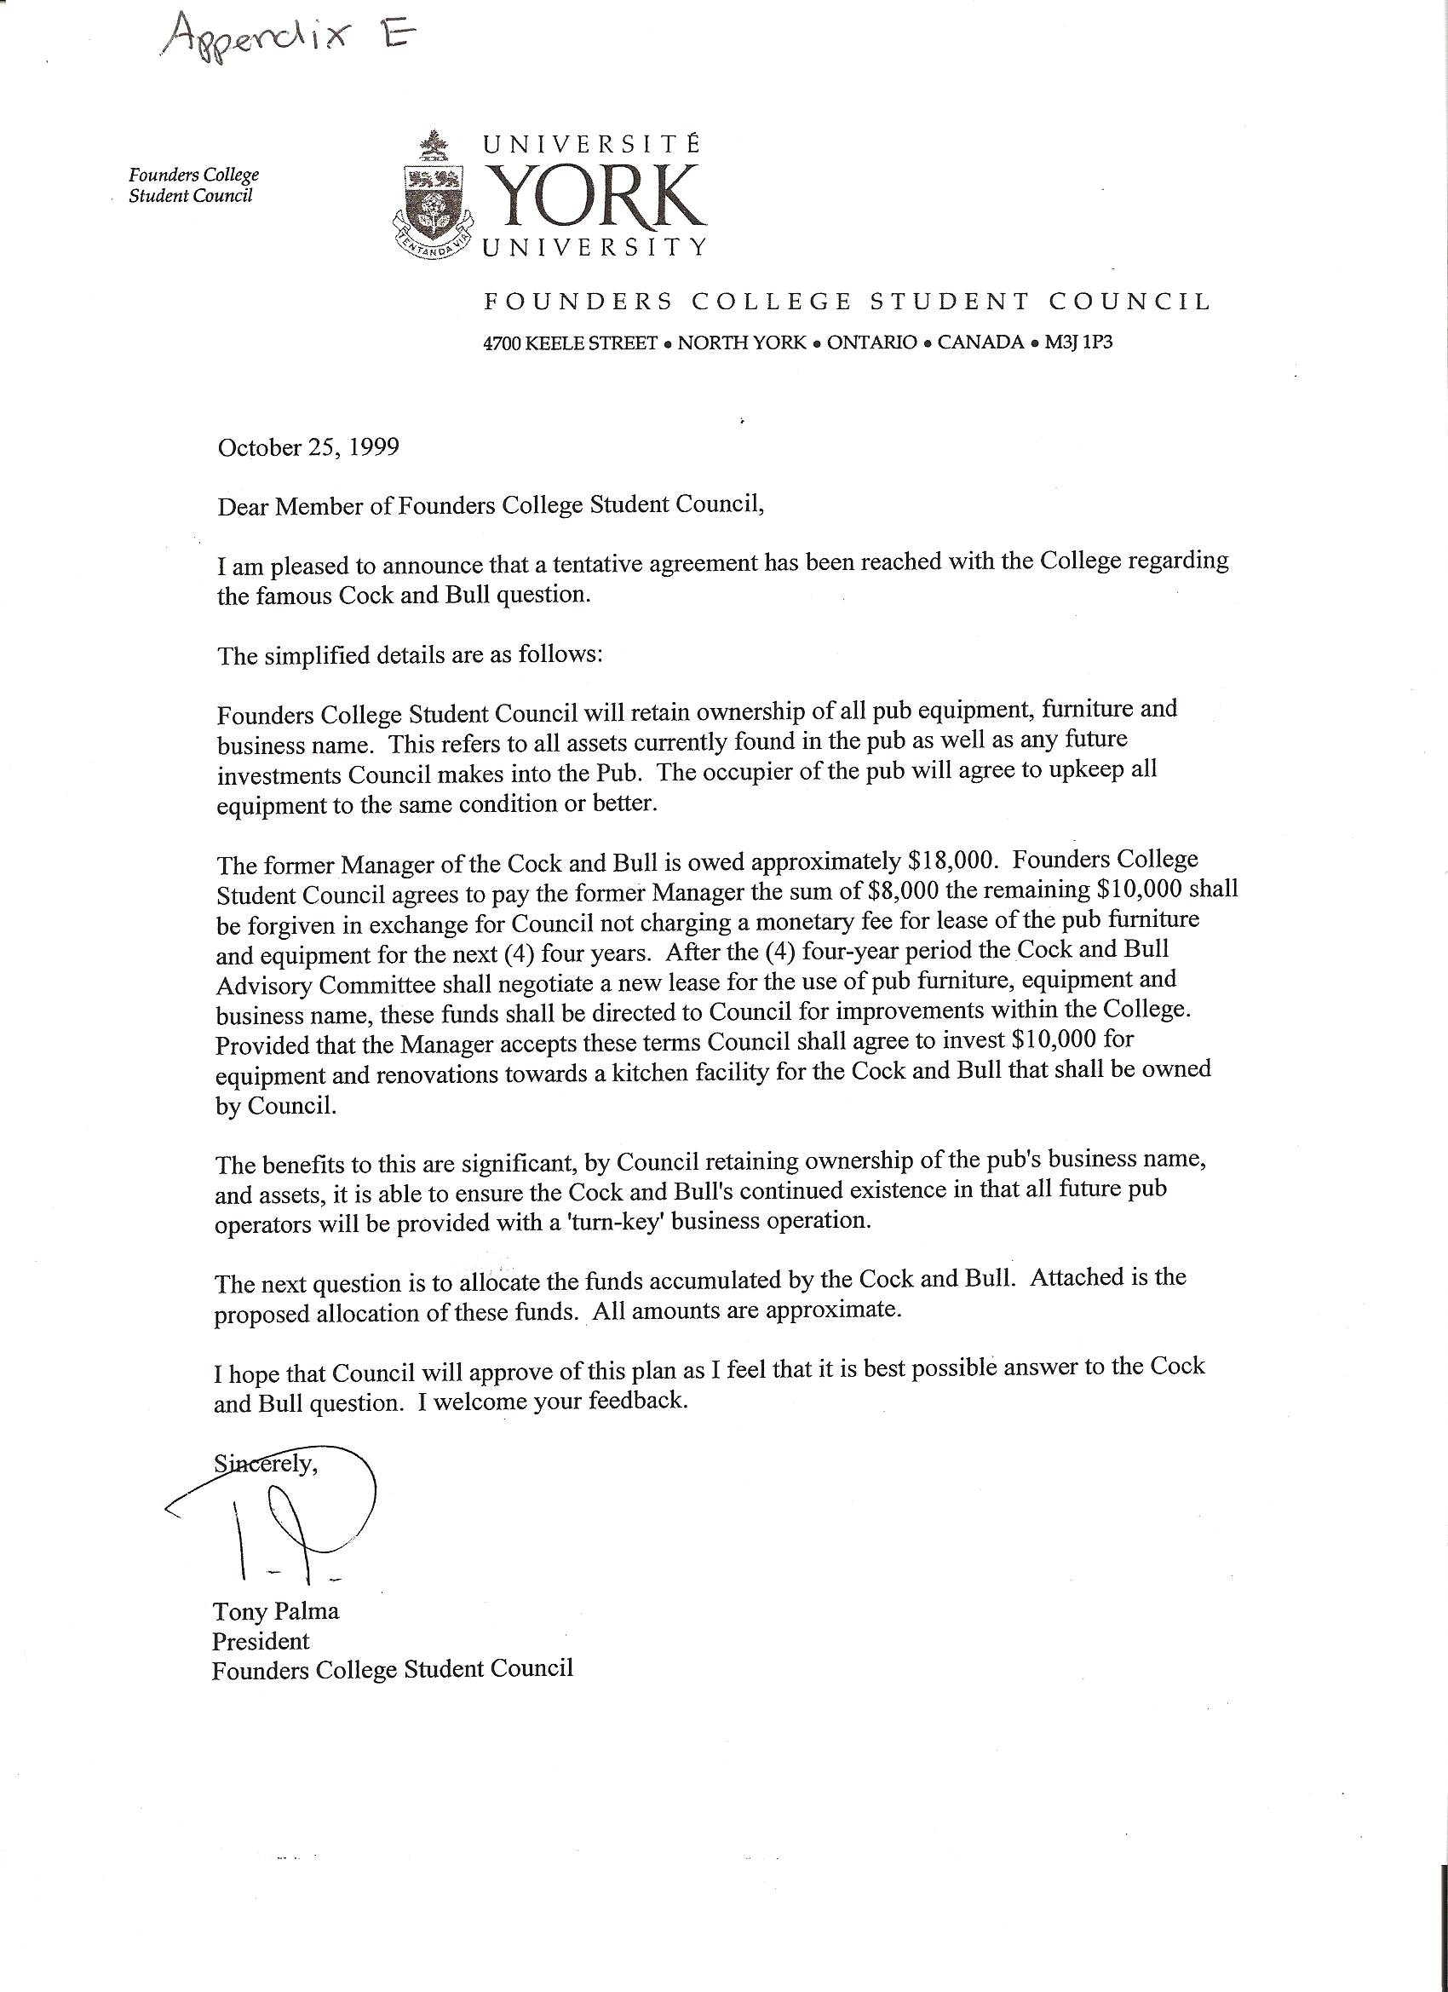

Appendix E-Continued
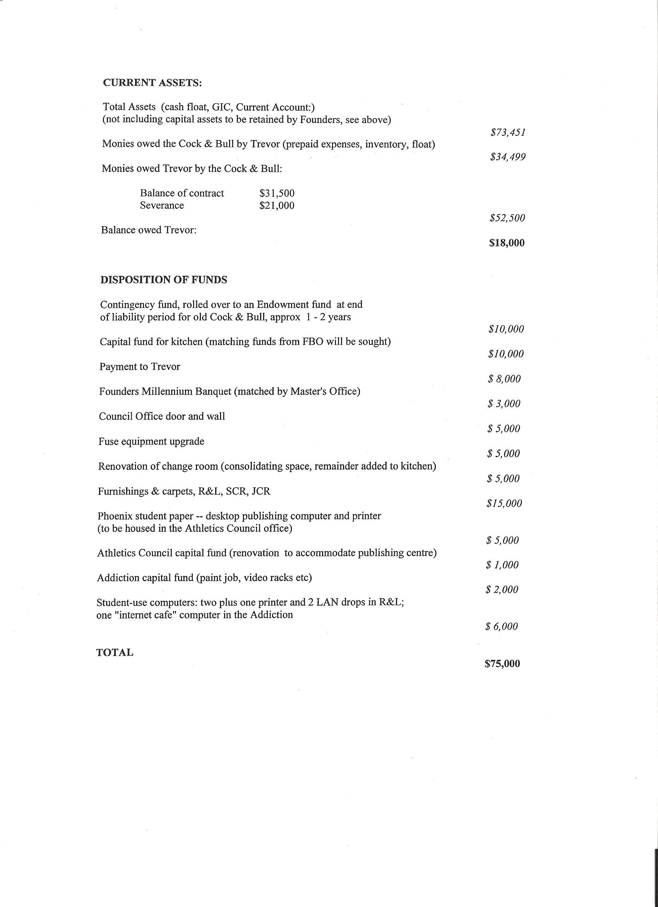

Appendix F
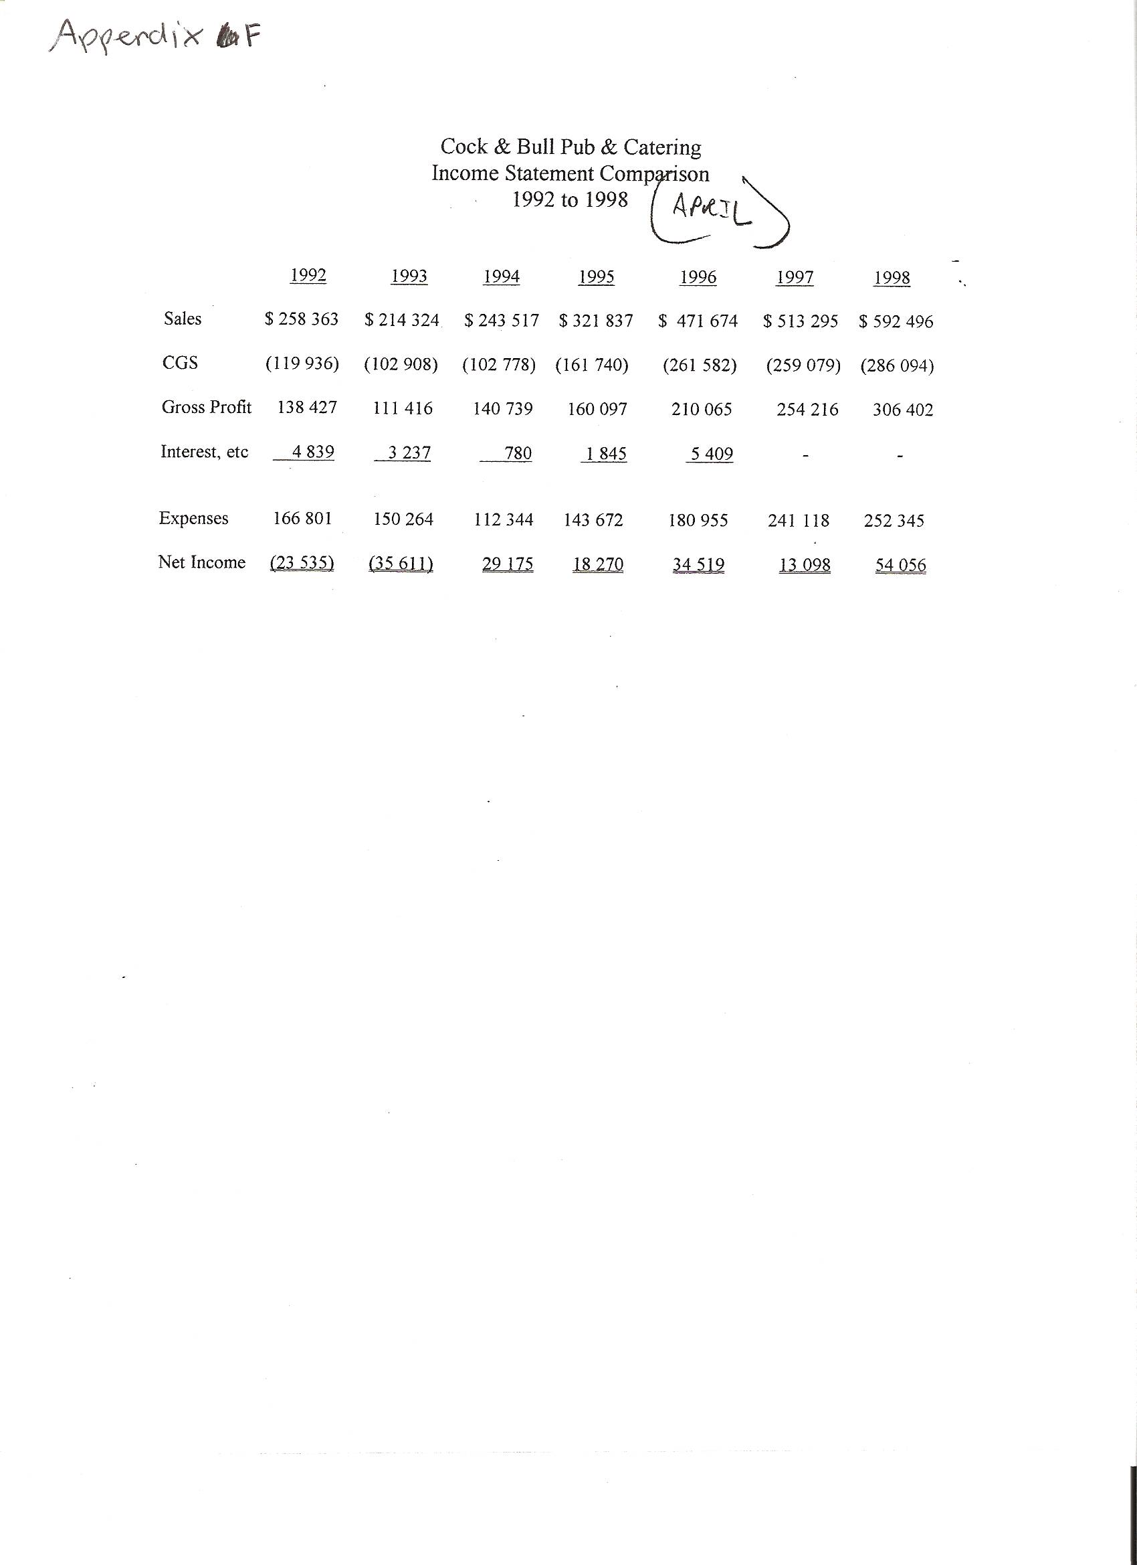

Appendix G
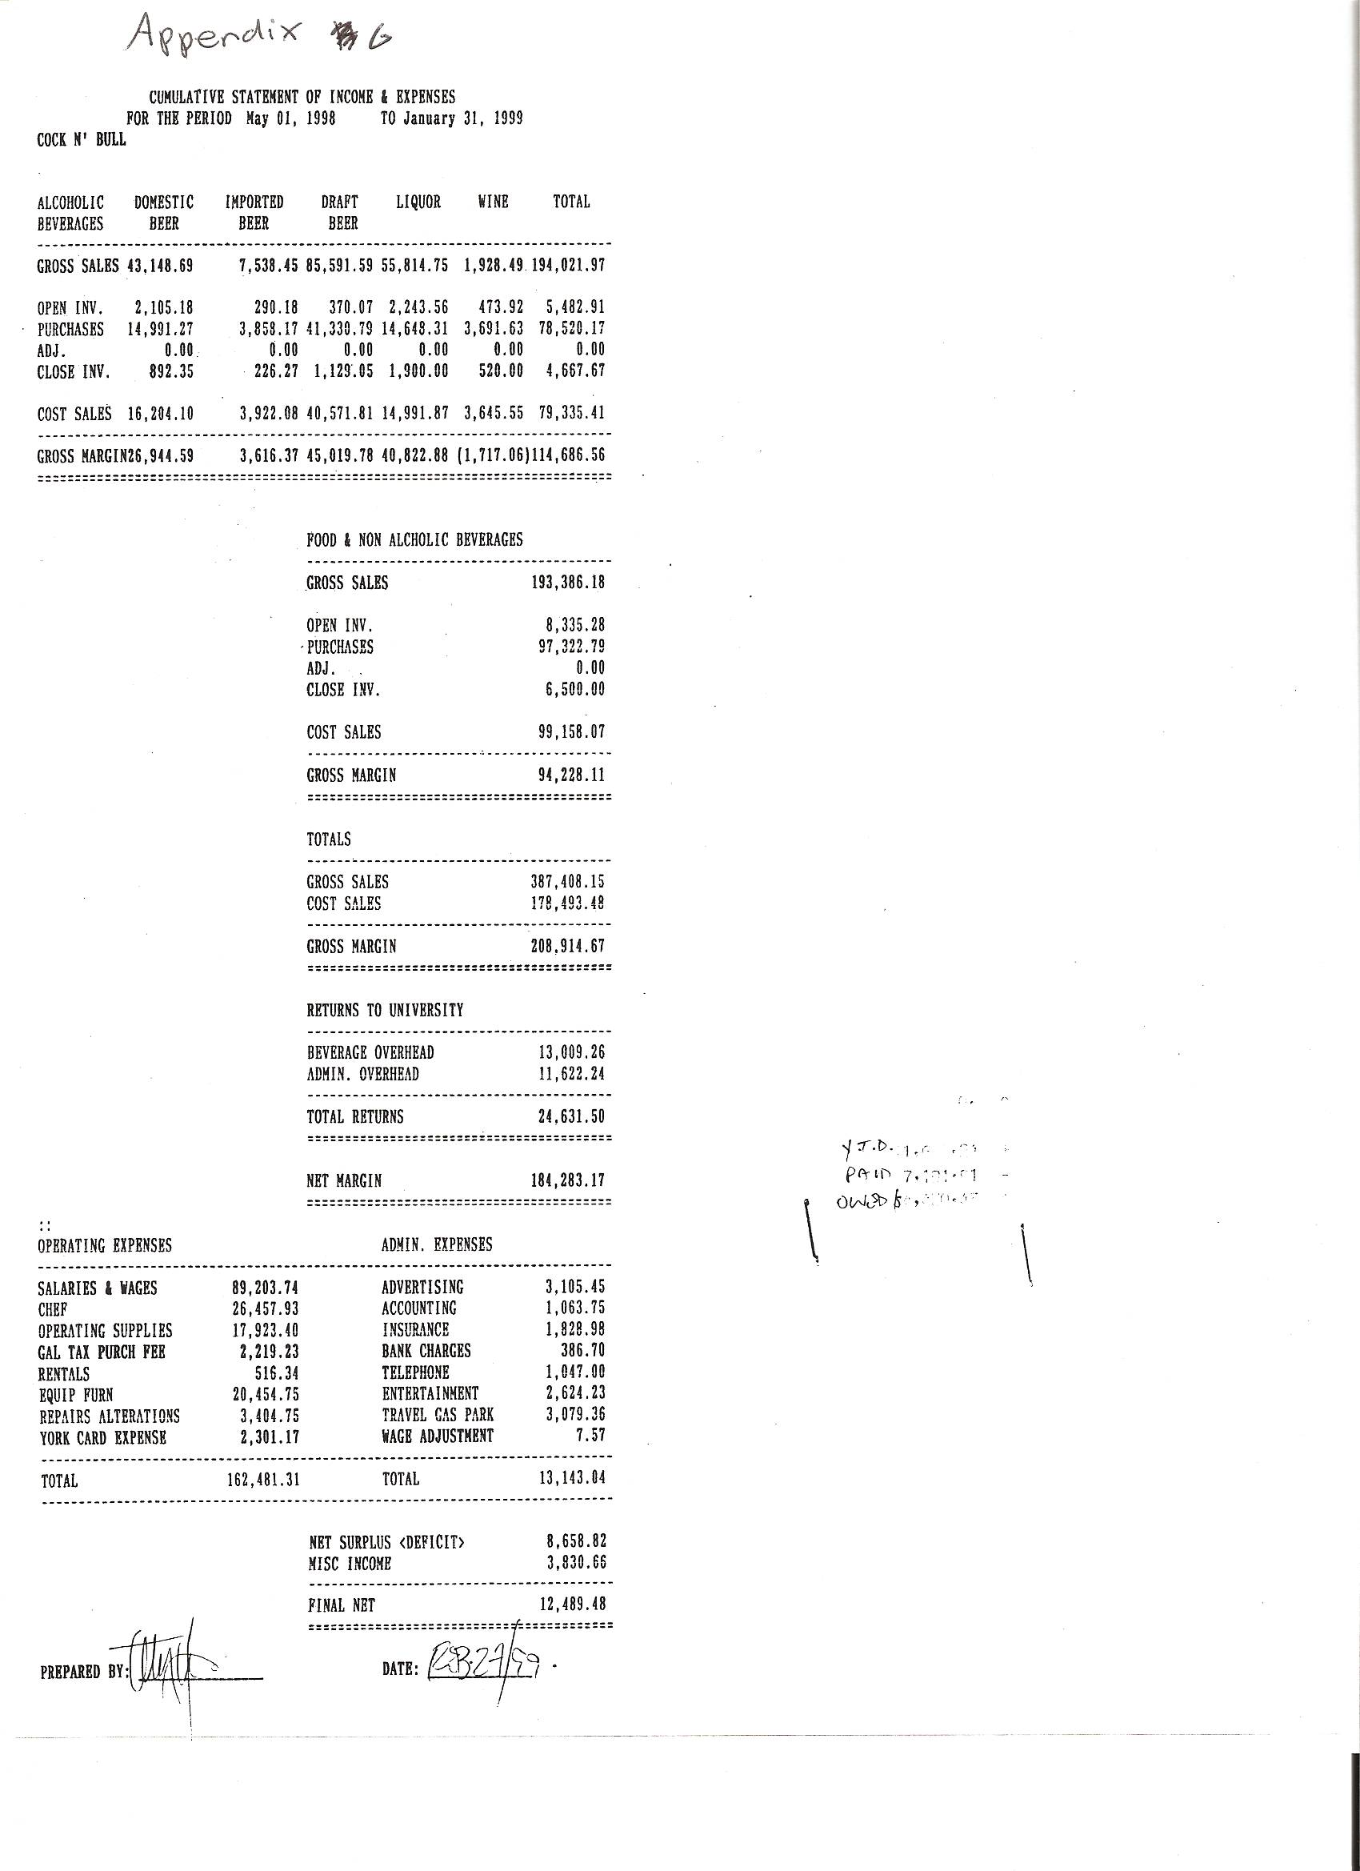

Report


